INTRODUCTION
This document describes the setup of custom command solution Hexagon Networks Portal provided to Powernet.

USAGE
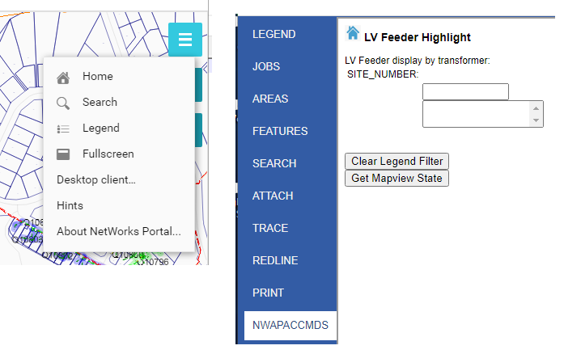
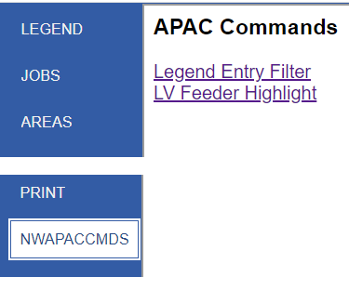Select command LV Feeder Highlight
The custom command will allow user to search for a transformer by Site Number.

User needs to key in first 4 characters, then custom command will perform a look ahead search with results presented in a list box
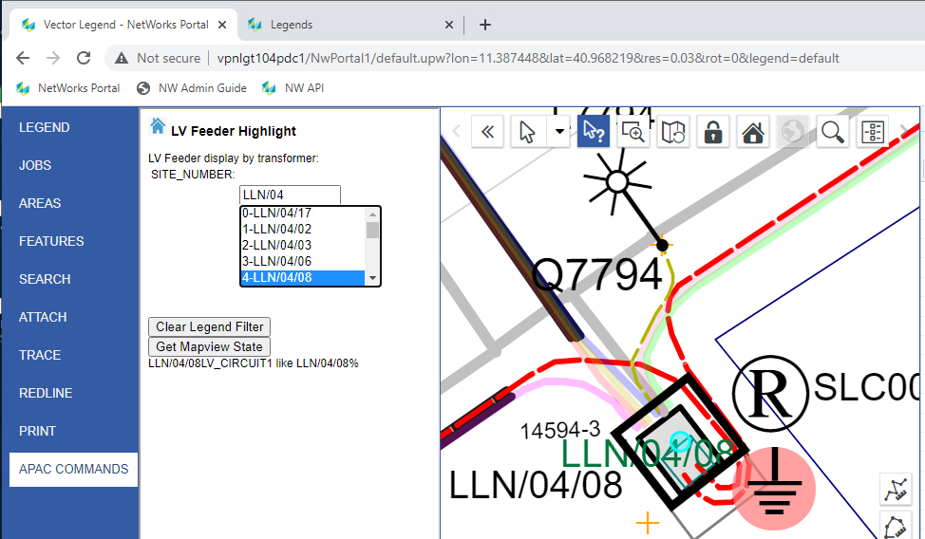

After user selects the desired transformer site number, map will update;
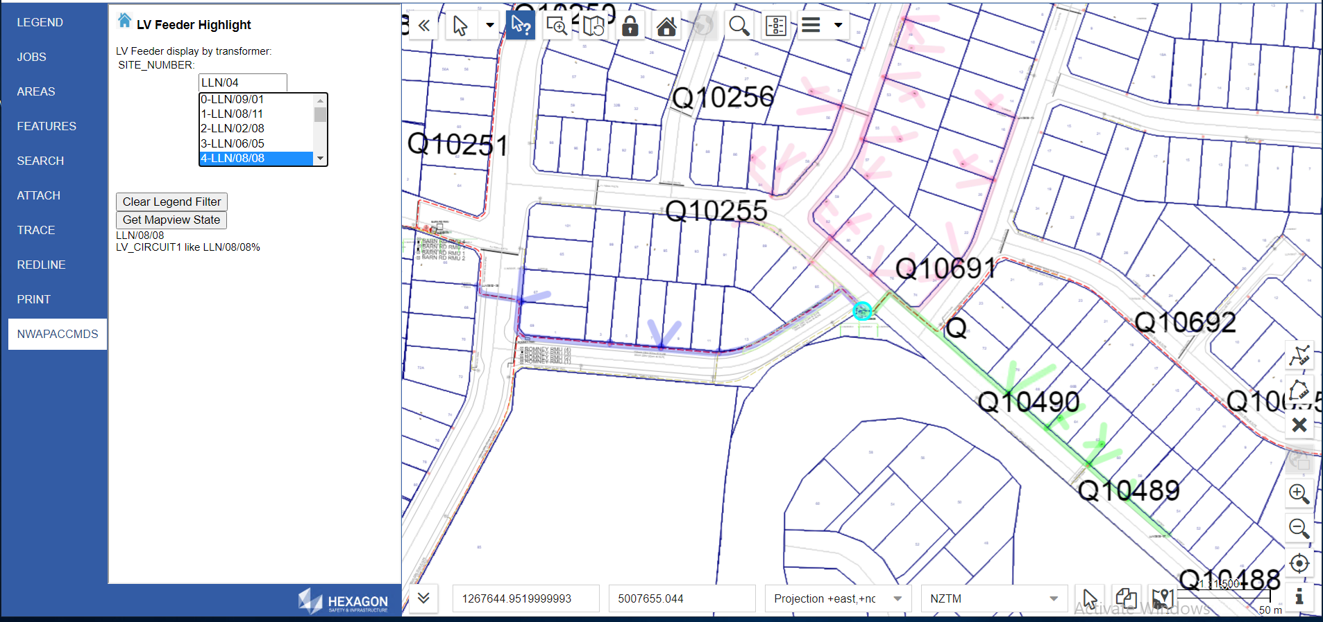
Clear Legend Filter button will remove the Legend Filter and uncheck the display of LV Feeder Highlight
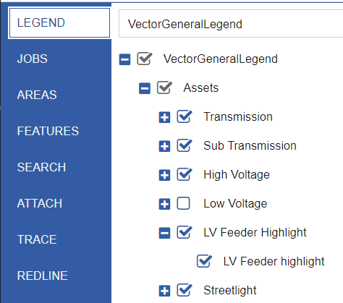

PREREQUISITES
Person installing should be familiar with;
- Hexagon Networks Portal version 02.00.2102.00070
- Client-side Javascript
Zip file that contains the Javascript and supporting files.

DEPENDENCIES
The custom command is dependent on the existing Hexagon Networks Portal deployment not changing.
If Portal is redeployed, the file Workspace.PNLPROD.xml will be reset to default, resulting in the link on left panel NWApacCmds being lost.
If the Analytical Service name changes the custom command will error with “not found”

SETUP
Custom command solution comes packaged in a ZIP file

Hexagon Networks Services
Identify the following Hexagon Networks web portal/services;
- NwPortal
- NwAnalyticalService

CUSTOM COMMAND FOLDER
Locate IIS default web folder wwwroot.
Un-zip into wwwroot as
\Inetpub\wwwroot\NWApacCmds

Hexagon Networks Portal XML config file
Identify name of Hexagon Networks Portal, e.g. NWportal1
Locate file Workspace.PNLPROD.xml
In file locate section
<Section type="function">
<Function name="sidebar">
<Config>
<JProperty name="items">
At end of section, between “<JValue>print</JValue>” and </JArray>
<JValue>print</JValue>
<!-- added start -->
<JObject>
<JProperty name="xtype">
<JValue>iframepanel</JValue>
</JProperty>
<JProperty name="title">
<JValue>NWApacCmds</JValue>
</JProperty>
<JProperty name="url">
<JValue>/NWApacCmds/default.html</JValue>
</JProperty>
</JObject>
<!-- added end -->
</JArray>
there is sample in Zip file

GLOBAL VARIABLES
Locate \Inetpub\wwwroot\NWApacCmds
Edit file LV_Feeder_Highlight.html
<script src="./jquery-3.5.0/jquery-3.5.0.js"></script>
<script>

//global parameters, changes depending on source web service
var sgURL = "/NwPortal1/default/services/search";
var sgURL2 ="/NwAnalyticalService1/search/execute/";
Change values to sgURL and sgURL2, as needed

